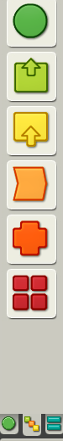
Happy Birthday

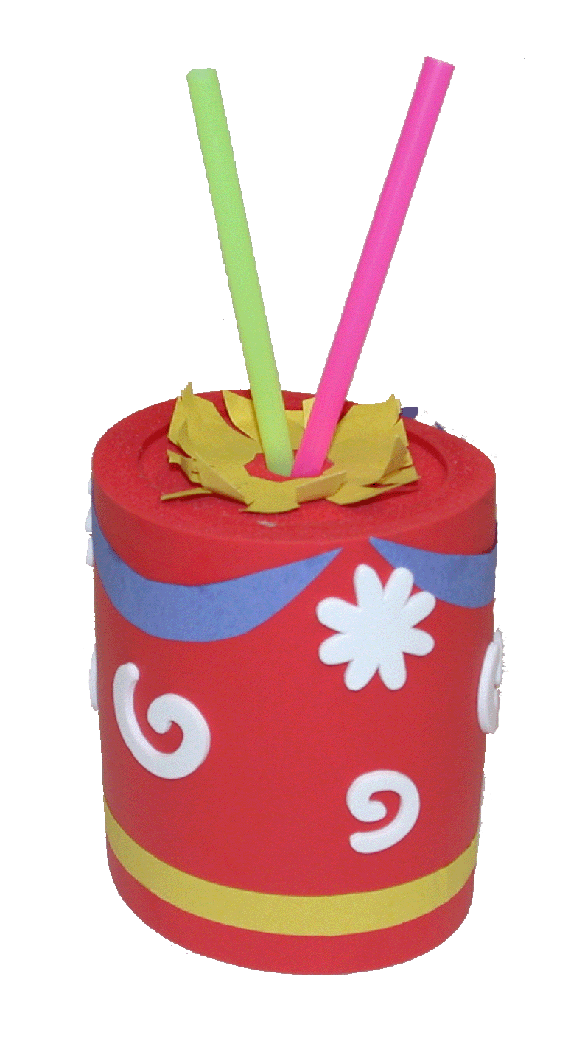
Start by Decorating Your Cake
Using a sound sensor, lamps, straws, a hallow cylinder and decorations, create an interactive birthday cake. It can cheer when you blow out the candles, or sing a song. It’s all up to you!
Add Candles
Connect white LEGO Lamps to black connector wires. Tape lamps to the ends of straws. The light will only shine a short distance, so you may want to use short straws. Once they’re taped together, add the candles to the cake.

Start by decorating the birthday cake.
Add candles; Turn the candles on; Incorporate sensors; and then add sound.
Incorporate Sensors

Put a sound sensor inside the cake, and program the lamps to turn off when you blow across the straws.
1st Block – Lamp* on
2nd Block – Wait for Sound
3rd Block – Lamp* off

Add Applause

Add applause after blowing out the candles.

4th Block – Sound (!Applause)

Play the Birthday Song
To play the birthday song, you will need to play one tone for each note. When a note is played twice in a row, you may want to put a “wait for __” seconds, so it sounds like two notes instead of one long note.

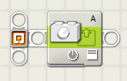
Turn the Candles On

To turn the candles on, use the
“complete palette.” To find the
green “lamp*” block, look in the collection of green “action” blocks. Watch closely, they won’t be on long! Can you find a way to keep it on longer?

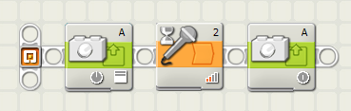

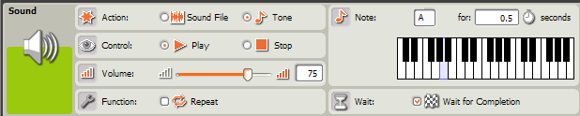
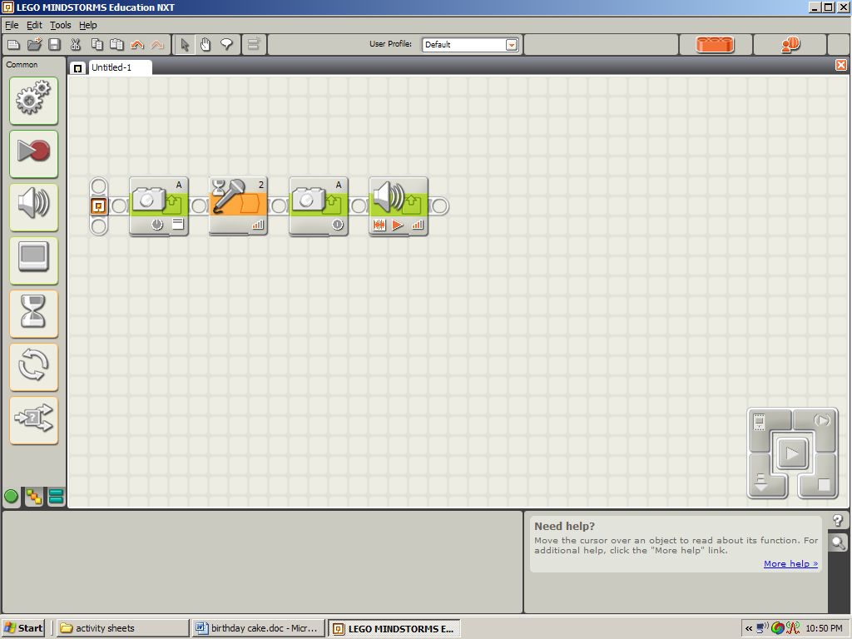

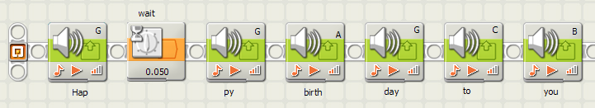
Notes for the G G A G C' B
Birthday Song G G A G D' C'
G G G' E' C' B A
F' F' E' C' D C'
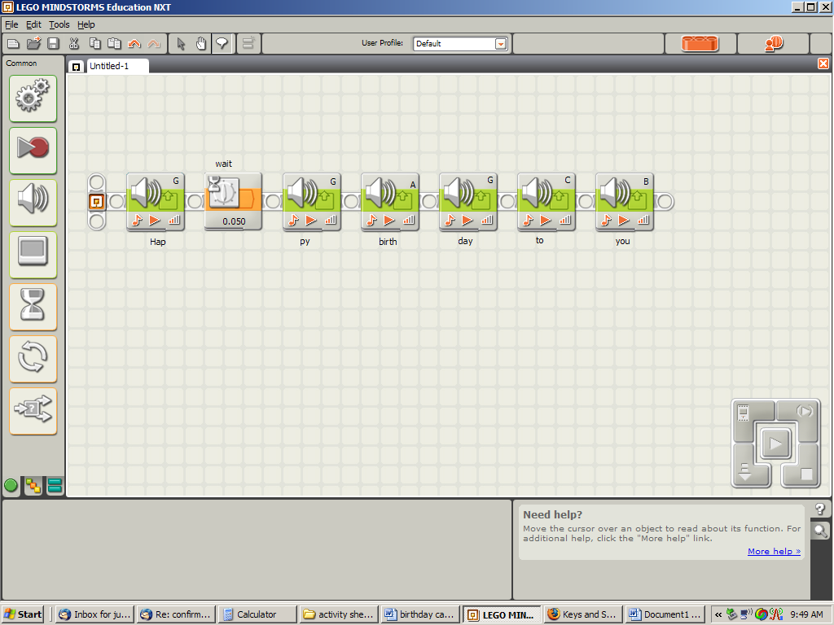
To write notes in your program, use the “comment tool”

